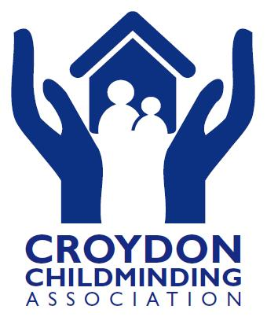
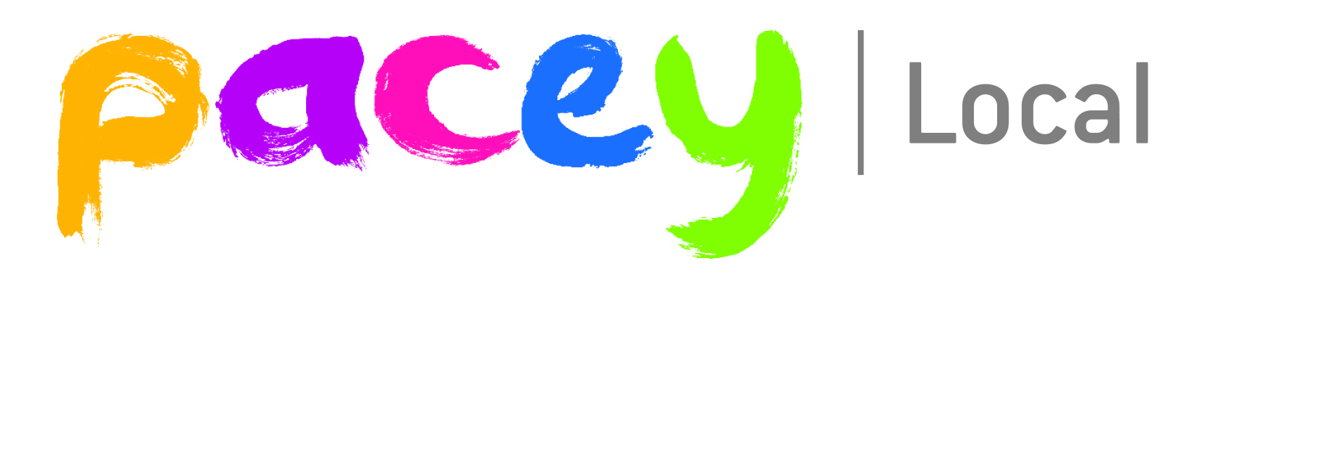

CCMA and PACEY Local Croydon Early Years Conference.
Saturday 13th May 2017.
Booking Form.
Name of Delegate:
Name of Setting:
Email Address:
Contact No:

Cost £40.00 per delegate (includes refreshments, hot 2 course buffet lunch).
Do you have any special dietary requirements?
Please make payment to: CCMA adding your name as reference to:
Lloyds Bank
Sort Code: 30-96-07
Account no. 00370553
Once you have made your payment, please email this form to Croydoncma@hotmail.com
We look forward to welcoming you.
Closing Date Monday 24th April 2017.
Bookings will be made upon receipt of payment.
*By signing you are agreeing to the CCMA Conference booking terms and conditions below
*Signature Date

Terms and Conditions
Organisers
Joana Smith at Croydoncma@hotmail.com Telephone 07983 862936
Payments
All bookings must be paid in full prior to the conference to guarantee registration. Payment should be made by direct bank transfer to the account detailed on the booking form using your name (or organisation name/lead coordinator for group bookings) as booking reference. Once payment has been received (and cleared) an email confirmation/receipt will be sent.
Access Requirements/Dietary Requirements
Delegates should advise of any special access or dietary requirements on the booking form.
Alterations to Programme – Cancellation/Postponement of Event
CCMA reserves the right to make alterations to the conference programme and timings
If there is a change to the advertised speakers, no refunds will be made.
In the event of it being found necessary, for whatever reason, that the conference is postponed or the dates changed, the organisers shall not be liable for any expenditure, damage or loss incurred by the delegate.
If by re-arrangement or postponement the event can take place, the booking between the delegate and the organisers shall remain in force and no refunds will be made.
In the unlikely event of the conference being cancelled a full refund will be made. Liability will be limited to the amount of the fee paid by the delegate.
Substitutions & Cancellations
All bookings are final and we regret that if a delegate is unable to attend for any reason no refunds will be made
Speakers
All speakers will be attending subject to availability and so cannot be guaranteed. If there is a change to the advertised speakers no refunds will be made.
Views expressed by speakers are their own. CCMA cannot accept liability for advice given, or views expressed, by any speaker at the conference or in any material provided to delegates.
Photography & Filming

For promotional purposes, there may be photography or filming taking place during the conference by the organisers or their representatives. By attending this conference you give consent for any photographs or videos taken at the event to appear on social media and the CCMA website. The organisers are not responsible or liable for any photographs or video taken at the event by delegates including if these are uploaded to the internet.

Data Protection

By submitting registration details, delegates agree to allow CCMA organisers to contact them regarding their services. Delegates who do not wish to receive such communications please email croydoncma@hotmail.com. Delegate names will be compiled onto delegate lists for the conference so that all attendees can see who is at the conference for the purpose of networking and meetings. The contact details of registered delegates will not be shared.

Websites & Links

The CCMA website may link to other websites and networking tools provided for the convenience of the users. The contents of these websites are maintained by their owners, for which CCMA takes no responsibility. Neither can responsibility be taken for contents of any website linking to this website.

Insurance

In the event of industrial disruption, travel disruption or other unforeseen circumstances, CCMA accepts no responsibility for loss of monies incurred by delegates. Delegates should make their own arrangements with respect to personal insurance, along with travel insurance.

CCMA cannot be held liable for any loss, liability or damage to personal property.

Contact us if you need any further information or have any questions at
- croydoncma@hotmail.com
- Like our Facebook Page at Croydon Childminding Association
- Visit our website at http://www.croydoncma.org.uk

